Sitting Together
Lesson #4: Eph. 2:11-22

Introduction

Some background:

The first Christians were Jews and the church required any male converts to be circumcised. But then Philip baptized an Ethiopian eunuch. He couldn’t be circumcised (already castrated-see Acts 8). Then Peter has his vision about eating animals that were ceremonially unclean (Acts 10). Then Saul becomes the apostle Paul sent directly to the Gentiles. (Acts 11-28).

The early church faced this controversy with the Jerusalem Council (Acts 15) where they decided not to require circumcision for church membership. But there was still tension in the early churches as the membership of Gentiles grew.

Paul’s goal for the Jews and Gentiles is to be reconciled into ONE body: “And in Him you too are being built together to become a dwelling in which God lives by His Spirit.” (2:22)

A word about those terms:

Jews: The descendants from the tribe of Judah (one of Jacob’s sons). The actual word “Jew” comes the location (Judah) and a Latin to French version of Judah-“juju.” The modern term then is a mashed-up word referring to people from that region.

Gentiles: This term is also a combination of two other terms: “Goy” (in the Old Testament) or “ethnos” (in the New Testament). Both are translated “nation.” The Latin term was “gentillis.” “Gentiles” then, refers to any ethnic group, people group, family, or nation that is not from the 12 tribes of Israel. It refers to anyone who is not a Jew.

Before Christ, Jews and Gentiles were separated-on opposites sides of a wall of hostility

The Jews:
Citizens of Israel:
Descendants from Abraham (Gen . 12, 15(, from Isaac (Gen. 26), from Jacob (Gen. 35), and from Judah (Gen. 49). The Covenant was renewed with Moses (Ex. 34). “Let MY Son (PEOPLE) go…” (Ex. 4:22-23)

Chosen and set apart (Amos 3:1-2 and Ps. 147:19-20) because of His great love, not because they were something special. See Deut. 7:7-9, 9:4-6.
The Gentiles:
“Foreigners and sojourners” (the “ger” in the OT): See Deut. 10:18 and Lev. 19:33
They were outside of the covenant relationship God had with Israel, but were to be blessed “through them.” (Gen. 12:3)

Paul says they were “without hope” and “without God in the world” (vs. 13) and “far away (vs. 14)

Circumcision vs. Uncircumcision:

A physical sign for all to see. An immediate way to identify God’s people.

For a literal, or physical way to see the separation, take a look at the outline of the temple:

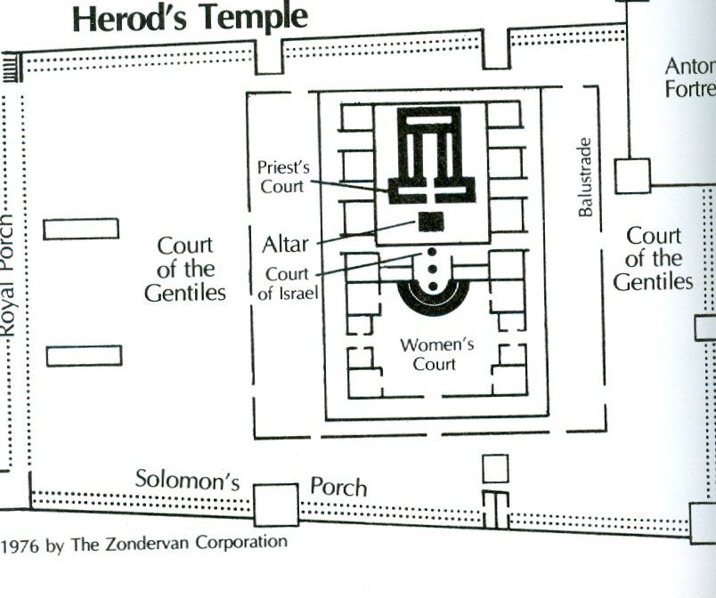

Brought Together in Christ:

Amplified Version: In Him the whole structure is joined (bound, welded) together harmoniously, and it continues to rise (grow, increase) into a holy temple in the Lord (a sanctuary dedicated, consecrated and sacred to the presence of the Lord ).

Brought Near: It "is not an external, dispensational, national, geographic, or ceremonial nearness—but is a spiritual intimacy of union with the Lord Jesus Christ. Every person who trusts in Christ alone for salvation, Jew or Gentile, is brought into spiritual union and intimacy with God.” (John MacArthur)

Destroyed the barrier between Israel and Gentiles
A spiritual barrier
A cultural barrier
A barrier within the church

Christ is our PEACE!

His Purpose:

- Reconciliation
One new Humanity

One Body, One Household of faith
Built on the foundation of the apostles and prophets
Cornerstone is Jesus (see Ps. 118:22)
“Dwelling”/building:
Literally: see Matt. 7:24, Luke 4:29
Spiritually: see Acts 20:32, Gal. 2:18

- Access to the Father by One Spirit (See Rom. 5:2 and Eph. 3:12)

- Built together as a dwelling in which God lives by His Spirit
The “building” is “fit together” in such a way (so mixed) that nobody can tell the difference.

So What?

The challenge remains for us today: “Let us therefore make every effort to do what leads to peace and to mutual edification.” (Rom. 14:19)

Let’s think about the kinds of things divide us?
Race, Culture, Income
Language, Worldview/Politics
Sin, Age, Gender
Life Stages (married, with children, widowed and so on)
And so on….

Let’s consider that can we do about it?

- Look in the mirror and remember Rom. 3:23 and Isa. 64:6
- Evaluate our reactions in light of the gospel
- Exercise patience with others
- Teach our children to ignore the differences they see (model truth)
- Build relationships with people who are different than us
- Vow to live in grace

Psalm 133:1-3 needs to be our anthem!

Sherry Worel (sworel@stoneybrooke.com)

